**BANK LOAN REPORT QUERY DOCUMENT**

1. **BANK LOAN REPORT | SUMMARY**

**KPI’s:**

**Total Loan Applications**



**MTD Loan Applications**



**PMTD Loan Applications**



**Total Funded Amount**



**MTD Total Funded Amount**



**PMTD Total Funded Amount**



**Total Amount Received**



**MTD Total Amount Received**



**PMTD Total Amount Received**



**Average Interest Rate**



**MTD Average Interest**



**PMTD Average Interest**



**Average DTI**



**MTD Average DTI**



**PMTD Average DTI**



**GOOD LOAN ISSUED**

**Good Loan Percentage**

**Good Loan Application**

**Good Loan Funded Amount**

**Good Loan Amount Received**

**BAD LOAN ISSUED**

**Bad Loan Percentage**

**Bad Loan Application**

**Bad Loan Funded Amount**

**Bad Loan Amount Received**

**LOAN STATUS**

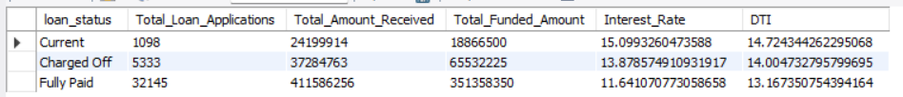

**MTD_Loan_Status**

1. **BANK LOAN REPORT | OVERVIEW**

**MONTH**

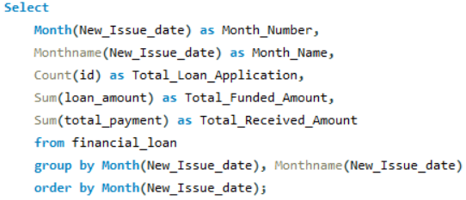

**STATE**

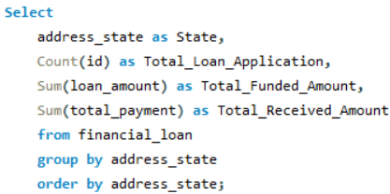

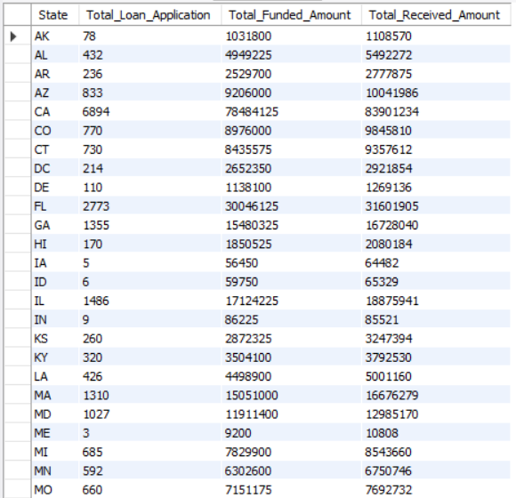

**TERM**

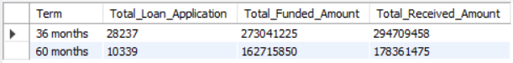

**EMPLOYEE LENGTH**

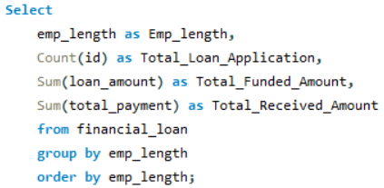

**PURPOSE**

**HOME OWNERSHIP**



